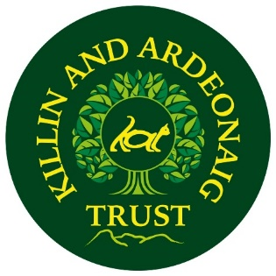
Killin and Ardeonaig Community Development Trust (KAT)

Annual General Meeting

Saturday 21st September 2024 at 10.30am
in the Community Rooms at Killin Church

- Welcome and introductions

- Apologies

- Adoption of Previous Minutes, 7th October 2023

- Chairperson’s Report

- Treasurer’s Report and Accounts

- Retirement and election of Office Bearers

Three Directors are required to stand down each year. Vicky Burns, Davy Fettes and Paul Godzik do so. Davy Fettes is not standing for re-election, Paul Godzik & Vicky Burns are willing to stand for re-election
- New applicants seeking election as Director

Co-opted Director to stand down

- Any other business

- Close formal AGM

Following the AGM there will be:
A series of spotlight sessions on our different projects.
Notes
Co-opted directors are appointed by the new Board of Directors
All Office Bearers retire from post at AGM and posts are voted on by Directors at the next board meeting.

